DRAMA: TOYS
- Match the words to the pictures
1 play dominos-A | 3 dresser | 5 stuffed animals | 7 play catch
2 play with an airplane | 4 closet | 6 play video games | 8 play with blocks

A 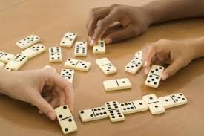 | B
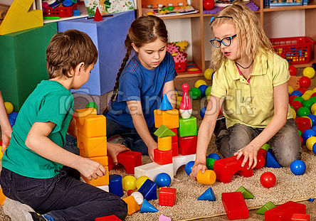  C | D
E 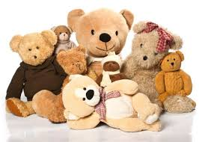 | F 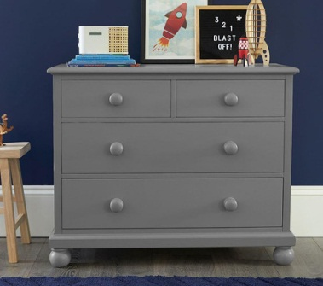
G 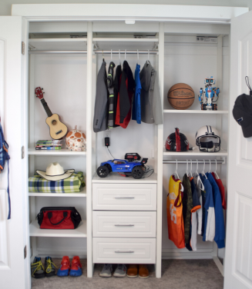 | H

- Watch the video. What other toys are in the video?

- Read the sentences. Choose the correct answer A, B, C or D.
Example: The airplane is
a) in the closet  b) in the box | c) on the dresser  d) under the bed
- The boys want to play
a) with the videogame  b) with the airplane | c) dominos  d) catch
2. The blocks are
a) with the stuffed animals  b) in the closet | c) near the airplane  d) under the bed
3. In the box there are
a) dominos  b) trucks | c) stuffed animals  d) board games
4. The ball is
a) in the closet  b) under the bed | c) on the dresser  d) in the toy box

Watch the video and check
- Put the dialogue in order. Then watch the video and check.

__ A. – Do you want to play with the video game or do you want to play with the airplane?
__ B. – Where’s the airplane?
__ C. – Do you have any trains?
9. __ D. – No, I want to play catch.
__ E. – Yes, do you want to play with the trains?
- __ F. – Let’s play!
__ G. – Ok.
__ H. – It’s on the dresser.
__ I. – Look at my toys!

