DRAMA: SCHOOL LIFE
- Watch the video. What’s the problem?
- Put the dialogue in order. Then watch and check.
I’m Anna.
Welcome to our school.
Hi!
Hi, I’m Adam. It’s the first day at school.
This is our friend Olivia.

- Name the school objects in the pictures. Use the words from the box.
Crayons eraser ruler backpack paper pencils English book markers

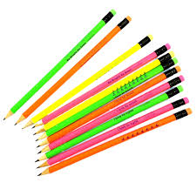
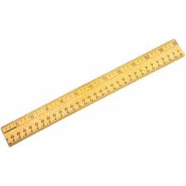
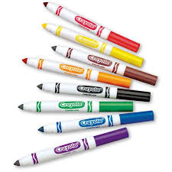
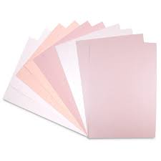

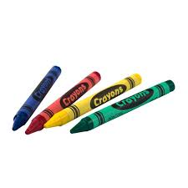
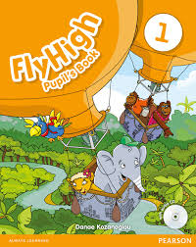
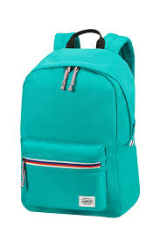
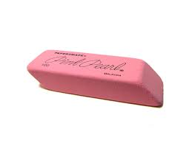

Watch the video and check.

- Watch the video and choose the correct option A, B or C
- What has Anna got in her hands?
- a notebook b) paper c) a book
- What has Olivia got in her backpack?
- three pencils and four markers
- three pencils and three markers
- four pencils and four crayons
- What colour is Adam’s backpack?
- pink b) blue c) black
- Adam’s got
- Anna’s backpack b) his backpack c) Olivia’s backpack

