DRAMA: PARTY TIME
- Match the words to the pictures

pizza - C a birthday cake fruit juice
a hot dog a hamburger grapes ice-cream a cupcake

A 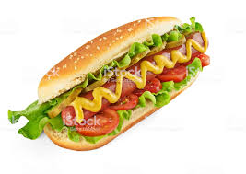 | B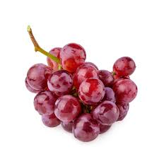 | C 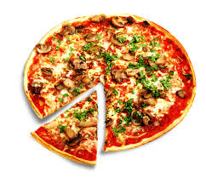
D | E 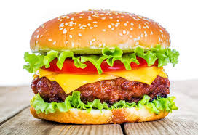 | F
G 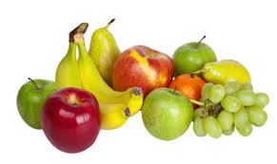 | H | I 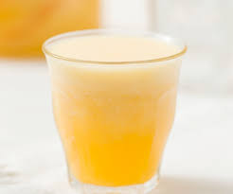

- Watch the video. What are the children making?

- a dinner party
- a surprise party
- a garden party

- Choose the correct answer a, b , or c.

Example: Children are making
- a pajamas party
- a welcome home party
- a birthday party

- Kids prepare a surprise party for
- Olivia b) Adam c) Anna
- Olivia likes
- cupcakes b) birthday cakes c) both
- For her birthday Anna likes
- salmon and fruit b) salad and fruit c) salad and fries
- Olivia likes
- piñatas b) pea nuts c) pancakes
- Olivia’s birthday is
- on Sunday b) in summer c) on Saturday
- For this birthday Olivia wants
- hotdogs b) hamburgers c) pizza
- Anna and Olivia like
- fruit b) ice-cream c) salad
Watch the video and check

