Drama: Family
- Watch the video. Who’s got a pet?
- Look at the family tree and finish the sentences.
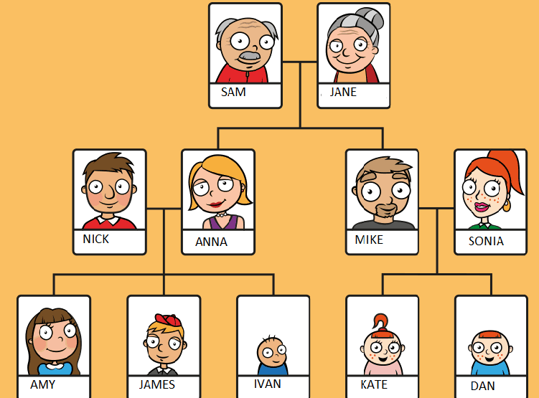
Example: Ivan is James and Amy’s baby brother.
      - Nick is Ivan, James and Amy’s ________________.
      - Anna is Mike’s _______________________.
      - James is Nick and Anna’s _____________.
      - Kate is Mike and Sonia’s ___________________.
      - Sam is Ivan’s ______________________.
      - Jane is Dan’s _________________________.
      - Anna is Amy, James and Ivan’s __________________.
      - James is Amy and Ivan’s ________________________.

- Watch the video again and choose the correct option A, B or C
- Olivia’s got…
- a mother, a father and a baby brother.
- a mother, a father and a sister.
- a mother, a father and a brother.
- Anna’s got…
- two sisters and a baby brother.
- two brothers and a baby sister.
- two brothers and two sisters.
- Adam’s got…
- two brothers and a dog.
- a grandmother, a grandfather and a dog.
- a grandmother, a grandfather and a brother.

