DRAMA: BODY
- Before you watch. Match the pictures to the sentences.
Example: She’s got her hands in her pockets. – F

- She’s got a ball in her hands.
- Her foot is on the ball.
- Her hands are on her head.
- Her hands are on her knees.
- She’s got long brown hair.
- Her hair is blond and wavy.
- She’s got short red hair.

A | B | C 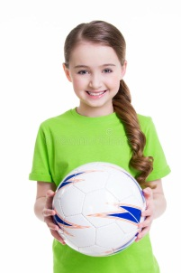 | D
E 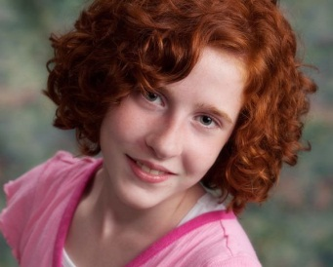 | F 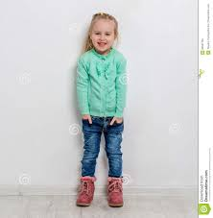 | G 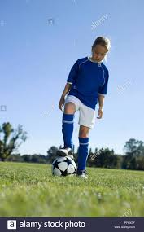 | H 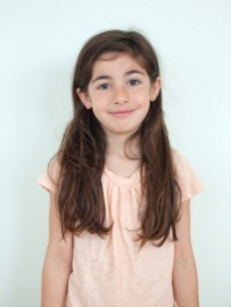

- Watch the video. Choose the words in the sentences to describe Emma.
Emma is from Belgium/Burma/Brazil. She is wearing a brown / blue / black shirt. She’s got long/short hair. Her hair is blond/brown/red. She’s playing tennis/football/basketball.

- Put the dialogue in order. Then watch and check.
- She’s from Brazil.
- Let’s play!
- Hi, Emma! Nice to meet you.
- - Hi!
- This is Emma.
- Emma, this is Olivia.

- Watch the video and mark the sentences T (true) or F (false)
Example: Anna and Olivia are running. - F

- Olivia knows Emma.
- Emma’s got short blond hair.
- Emma’s got long dark-brown hair.
- Emma has her foot on the ball.
- Emma has her hands on her head.
- Olivia invites Emma to play.

