DOCUMENTARY: BODY
- Before you watch
Write the missing letter in the words.
Example: he a d
e __ e | h __ nd | nos __ | l __ g
e __ r | m __ uth | ha __ r | a __ m
- Match the words to the pictures
1 ear | A | 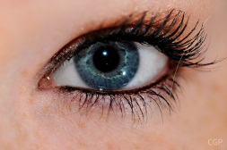
2 hand | B | 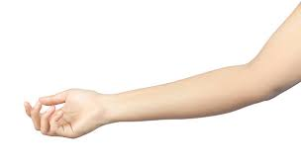
3 hair | C | 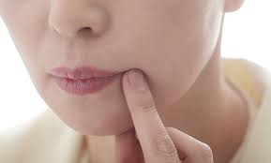
4 eye | D | 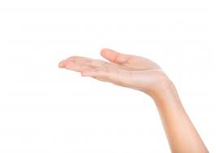
5 mouth | E | 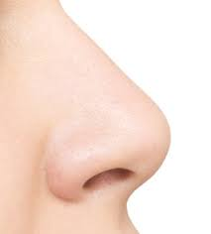
6 leg | F | 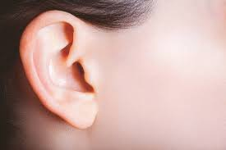
7 arm | G | 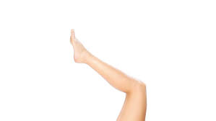
8 nose | H | 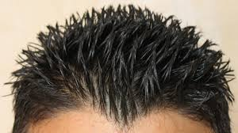
Watch the video and check. Which words are NOT in the video?

- Watch the video. Match parts of body with actions
Example: - We see with our eyes
- We feel with ________________
- We listen with ______________
- We use ___________ to read.
- We hear with _______________.
- We smell flowers with our _____________.
- We taste food with our ________________.

Watch again and check.

