DOCUMENTARY SCHOOL
- Before you watch
Write the missing letter in the words.
Example: r e d
gre n | wh te | p __ rple
bl e | p __ nk | or __ nge
br wn | bl __ ck | yel __ ow
- Match the words to the pictures
fireworks | 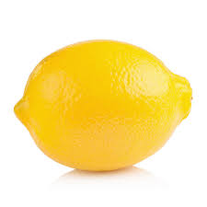
a frog | 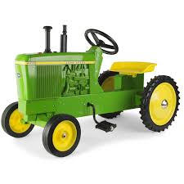
worms | 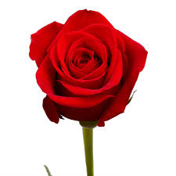
bananas | 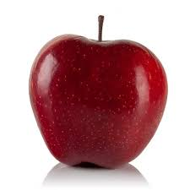
lattice | 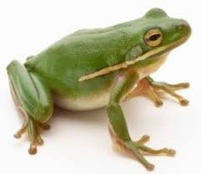
a lemon
a flower | 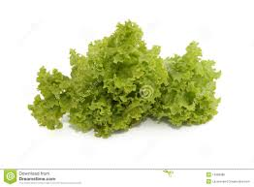
a tractor | 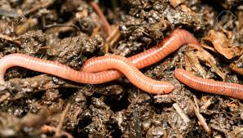
an apple | 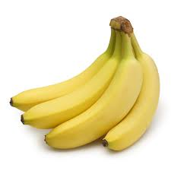
Watch the video and check.

- Watch the video and number the things as you see them

1 | - a green apple
 | - a red tractor
 | - a yellow rose
 | - pink worms
 | - green lattice
 | - a rainbow
 | - a green frog
 | - yellow bananas
Watch again and check.

- Finish the sentences
- Bananas are yellow.
- Frogs are ________________.
- Apples are ______________ and _________________.
- Worms are _____________________.
- Lattice is ____________________.
- Lemons are _________________.
- The sky is ___________________.

