Documentary: Family
- Before you watch
Write the missing letter in the words.
Example: li o n
p __ ppy | m __ nkey | c __ lf | ch __ ck
k __ tten | giraf __ e | elep __ ant | go __ t
- Match the words to the pictures
1 a baby elephant | A
2 a baby goat | B | 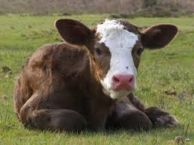
3 a baby giraffe | C | 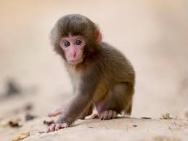
4 a puppy | D | 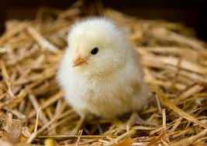
5 a kitten | E | 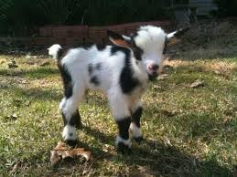
6 a calf | F
7 a baby monkey | G | 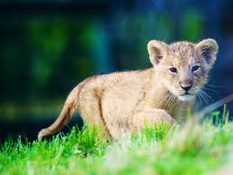
8 a chick | H | 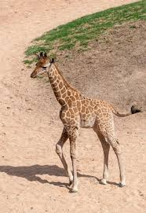
9 a baby lion | I | 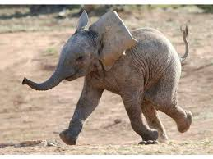
Watch the video and check.

- Watch the video Read and choose the correct number: one, two, three, four or five.
Example: - one baby giraffe
- ____________ baby goats.
- ____________ kitten.
- ____________ puppies.
- ____________ baby lions.
- ____________ sister lions.
- ____________ brother lions.
Watch again and check.

