DOCUMENTARY: CLOTHES
- Match the words to the pictures
1 shorts - A 2 rain boots 3 T-shirt 4 trousers 5 gloves 6 jeans 7 sandals 8 skirt 9 raincoat

A 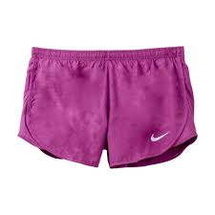 | 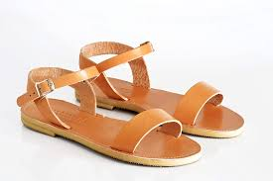B | C 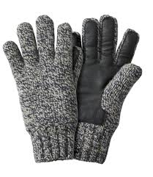
D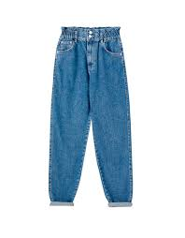 | E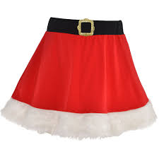 | 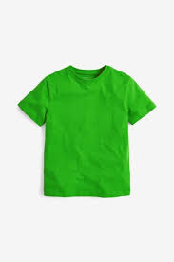  F
G 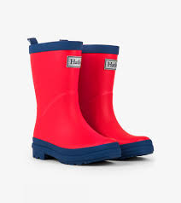 | H 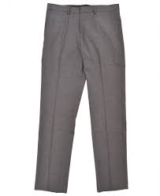 | I 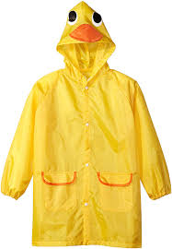
- Watch the video. Choose the right words to finish the sentences.
Choose from: warm, dry, wet, cool
- When it’s hot people wear clothes that let them stay ___________.
- When it’s wet people wear clothes keep them __________.
- When it’s cold people wear clothes keep them _________ .
- People wear raincoats when it’s ______________________ .
- Watch the video again. Put a (√) next to the sentences from the video. Put a (x) next to the sentences which are not.
Example: A girl and a boy are wearing shorts - F
- A girl and a boy are wearing T-shirts.
- A girl is wearing sandals.
- A girl is wearing a brown skirt.
- Two girls are wearing raincoats.
- Their rain boots are purple and blue
- The children are on the playground.
- Two boys are playing hockey.

