DOCUMENTARY: TOYS
- Match the words to the pictures
1 paper - A 2 tail 3 sticks 4 glue
5 string 6 markers 7 scissors 8 kite

A | B 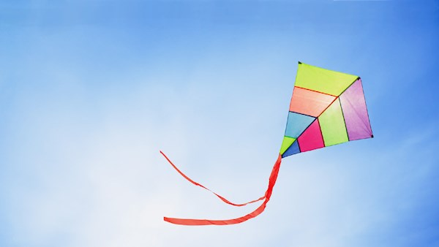
C 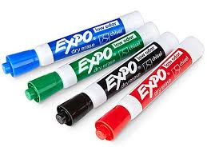 | 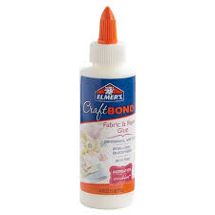  D
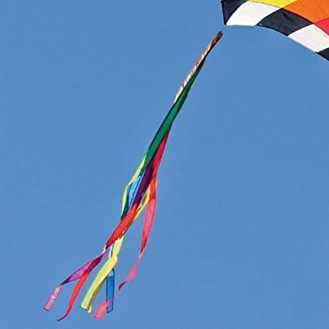  E | 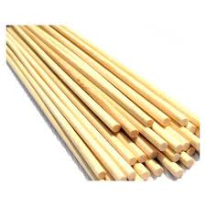  F
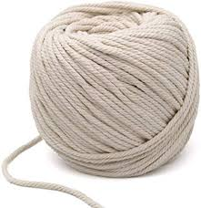  G | 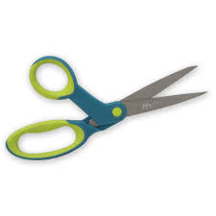  H
Watch the video and check.
- Fill in the gaps in the sentences with the words from the box. Use the pictures to help you. Then watch the video and check.
draw pictures | fly a kite | fold paper | cut paper
colour it with markers | make a tail | tie sticks with string
Example: It’s fun to 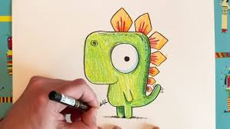 draw pictures.
- To make a kite you 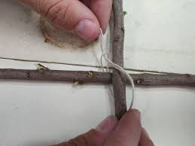 ______________________________.
- It’s fun to 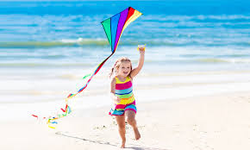 _______________________________.
- You __________________________ to make it smaller.
- We 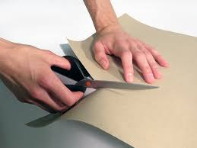 ______________________with scissors.
- You can 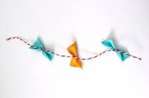______________________ for your kite from paper.
- To make your picture bright you 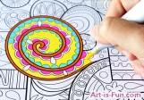 ______________________.
3. Watch the video again. Order the following sentences:
1. __ A. tie two sticks together with string
__ B. cut the paper
__ C. colour the kite with markers
10. __ D. make a tail
__ E. draw round the sticks
__ F. put the sticks on the paper
7. __ G. fold the paper over the string
__ H. tie a piece of string around the sticks
__ I. glue the paper
__ J. put the sticks on the paper
Now watch the video and make a kite with your parents or friends.

