DOCUMENTARY: HOME
- Write the missing letter.
Example: a house
a b _ droom | a ki _ chen | a h _ ll | a bas _ ment
a bal _ ony | a wind _ w | a ro _ f | sta _ rs
a livin _ room | a st _ dy room | a do _ r | a ba _ hroom

- Match the words from exercise 1 to the pictures

A 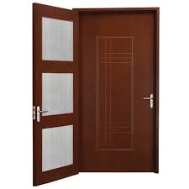 | B 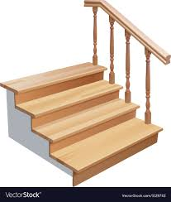 | C 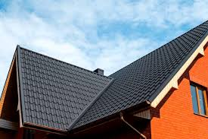
D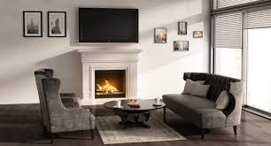 | E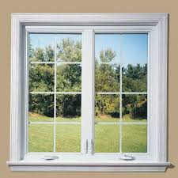 | F 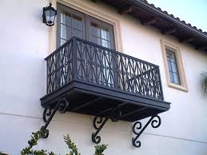
G 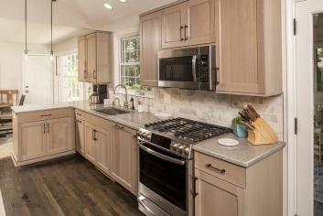 | H 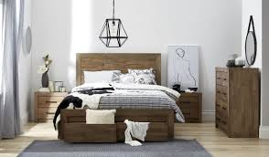 | I 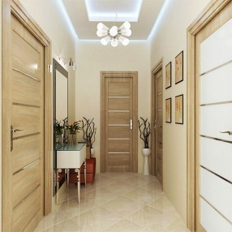
J 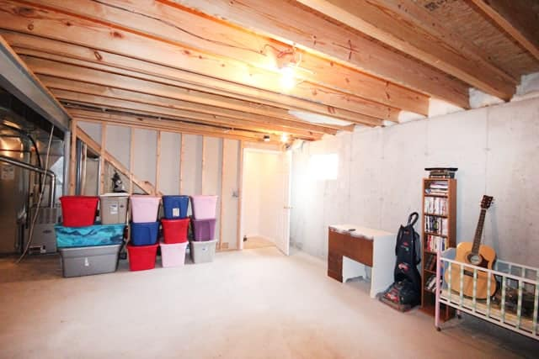 | K 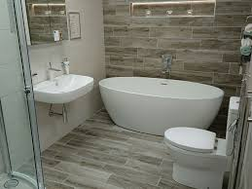 | L 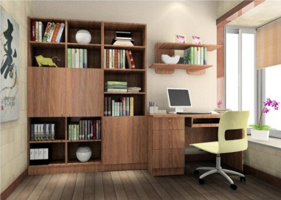

- Watch the video. Tick the words which are mentioned in the video.
a bedroom | a kitchen | a bathroom
a hall | a window | a roof
a living room | a study room | a door

- Choose the correct word to finish each sentence
Example: We eat in the kitchen/ living room/ hall.

- We sleep in the bathroom / bedroom / study room.
- We watch TV in the hall / study room / living room.
- We have a shower in the bathroom / bedroom /balcony.
- We do homework in the living room / kitchen / study room.
- We keep things that we don’t need in the balcony / basement / hall.
- We cook in the balcony / kitchen / hall.

