DOCUMENTARY: ANIMALS
- Write the missing letter in the words. Then choose the right words for the pictures below.
Example: a pet
1. a d – g | 3. a ho _ se | 5 a r _ bbit
- a c - t | 4 a gold fi _ h | 6 a h _ mster

A | B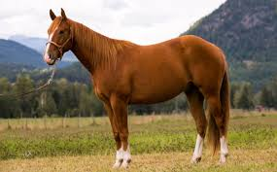 | C
D | E | F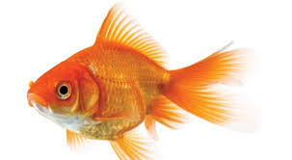

- Watch the video. Tick (√) the pets that are mentioned?

1 – dogs
2 – rabbits
3 – horses
4 – hamsters
5 – cats
6 - goldfish

- Tick (√) the things that happen in the video.
1 – a dog is running
2 – a cat is playing
3 – a cat is sleeping
4 - a dog is playing with a ball
5 – a dog is resting
6 – a girl is riding a horse
7 – a boy is feeding his cat
8 – goldfish are eating

Watch the video and check

