CULTURE: PLAY TIME
- Match the words to the pictures

 | 1 paddle boarding |  | 4 surfing |  | 7 snowboarding
 | 2 skateboarding |  | 5 windsurfing |  | 8 parkour
 | 3 hang gliding |  | 6 wakeboarding |  | 9 kitesurfing
A 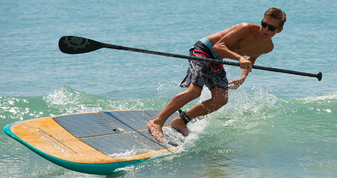 |  | B  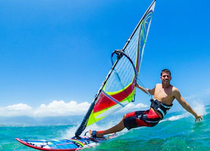 |  | C  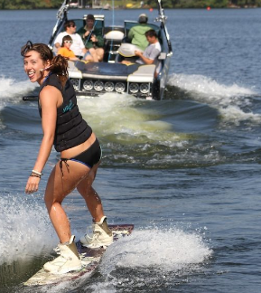
D  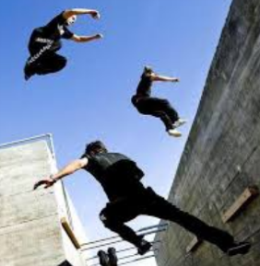 |  | E  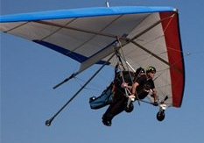 |  | F  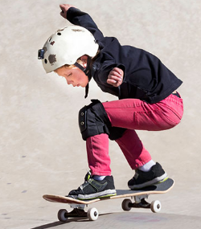
G  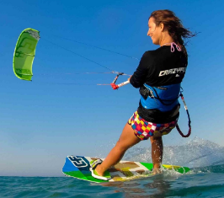 |  | H  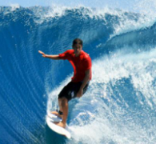 |  | I

- Watch the video. Tick (√) the activities that are mentioned.

1 – surfing- x  2 – skateboarding  3 – wakeboarding  4 – windsurfing | 5 – kitesurfing  6 – dancing  7 – hang gliding  8 - parkour
- Put T (true) or F (false) next to the sentences. Then watch the video and check.
Example: You can develop great talents by learning new skills. T

- Parkour is an individual sport.
- Parkour is similar to what Spiderman does in a movie.
- There is a school in London where kids can learn parkour.
- The skaters are proud of their skateboards.
- The dancers have won a National Dance Competition.
- Young skaters in the video are professionals.

- Tick (√) the things that happen in the video.
Watch the video and check

