CULTURE: PARTY TIME
- Match the famous landmarks to the pictures
- Taj Mahal - D | 5. Buckingham palace
- The Great Wall | 6. St Paul’s Cathedral
- The White House | 7. Westminster Abbey
- Tower Bridge | 8. Houses of Parliament

A 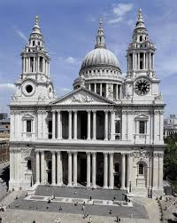 | B 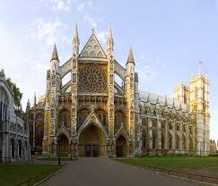
C 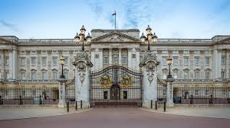 | D 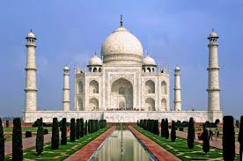
E | F 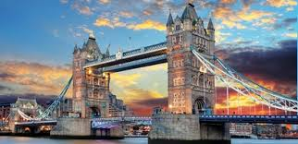
G 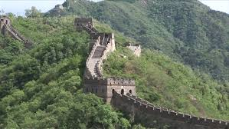 | H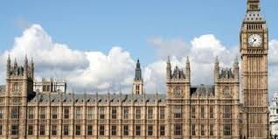
- Watch the video. What is it about?
A –parties B – cakes C – cake makers

- Which landmarks are mentioned?
- Taj Mahal | - Buckingham palace
- The Great Wall | - St Paul’s Cathedral
- The White House | - Westminster Abbey
- Tower Bridge | - Houses of Parliament

The Great Wall, the White House, Tower Bridge, St Paul’s Cathedral.
- Put T (true) or F (false) next to the sentences.
Example: There is a cake shaped like a smartphone. - T
- There’s a cake shaped like a fruit.
- Cakes shaped like designer bags are popular in India.
- A cake-replica of St Paul’s Cathedral was made by an ex-mechanic.
- A delicious art exhibition is held in London.
- American cooks used ginger bread to make their cake.
- A ten-metre long replica of the Great Wall is made of chocolate.
Watch the video and check

