CULTURE: BODY
- Match the words to the pictures
1 cello - F 2 drums 3 piano 4 guitar
5 trumpet 6 violin 7 harmonica 8 bells
9 accordion

A 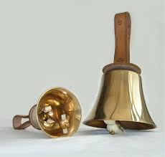 | 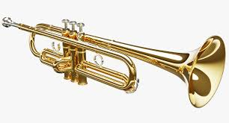  B | C 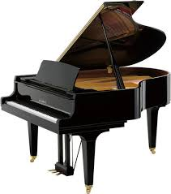
D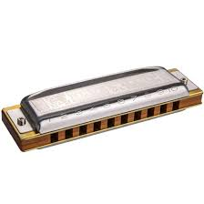 | E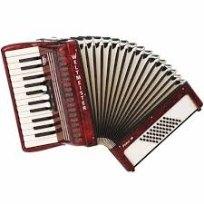 | 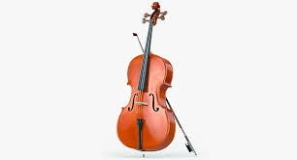  F
G 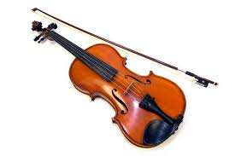 | H 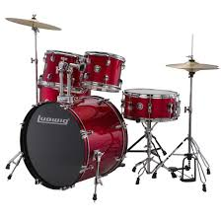 | I 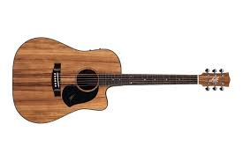
- Watch the video. Which instruments are mentioned?
- Tick (√) the correct answers A, B or C.
- Harnes had to
- train his hands
- change schools
- find a music teacher
- He stopped playing rugby because
- it was unsafe
- it was hard to be the best
- he was too young
- Eye-tracing technology makes it possible
- to help your eyes relax
- to develop new music style
- to play music with the help of eyes
- To play the drums the man uses his
- special sticks, sensors, drums, and fingers
- special sticks, sensors, feet, and hands
- special sticks , sensors, hands, and legs
4. Watch and listen. Put a (√) next to the things people use their hands for in the video. Put a (x) next to the things which are not mentioned.
Example: play a musical instrument (√)
- pick up things
- pantomime
- play a window
- drum on the table
- speak a sign language
- play the guitar
Watch the video again and check

